Student: Alan Danque

Professor: Anthony Armstrong

Week 3 Exercise: 3.2 - 3 tree maps, 3 area charts and 3 stacked area charts using Python, R and Tableau

Created using Tableau

Git Repo Location:

<https://github.com/adanque/DSC640>

All Python, R and Tableau twb scripts and dataset & generated plots are located on this Repo:

https://github.com/adanque/DSC640/tree/master/Week3

**3 tree maps**

Python

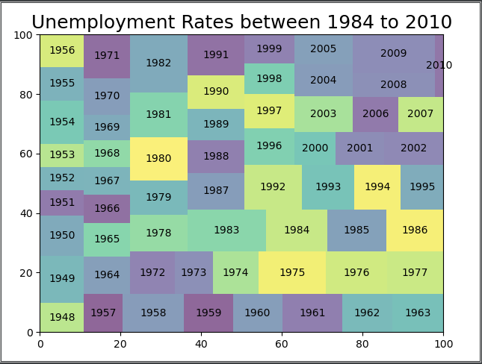

R

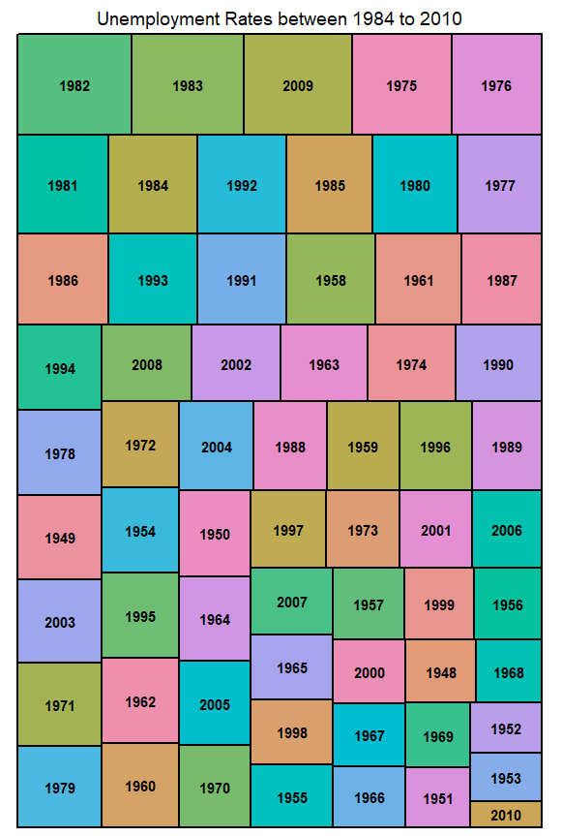

Tableau

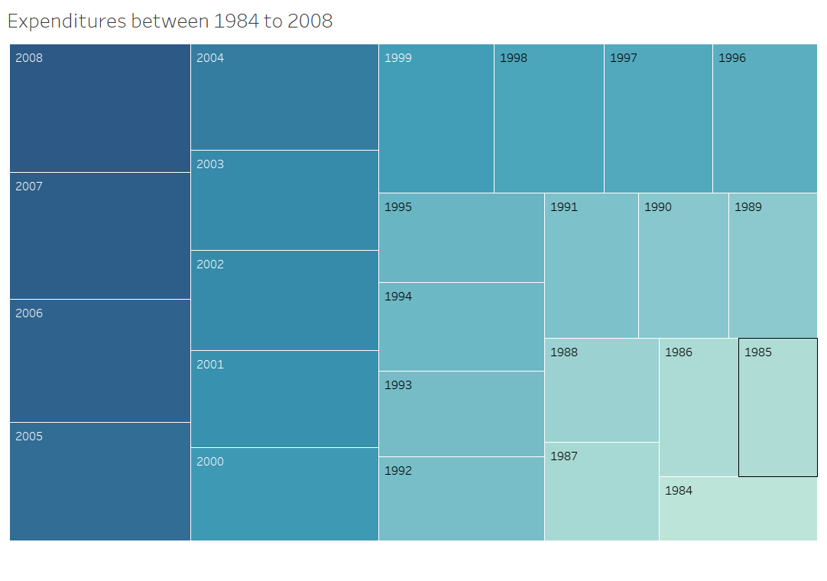

**3 area charts**

Python

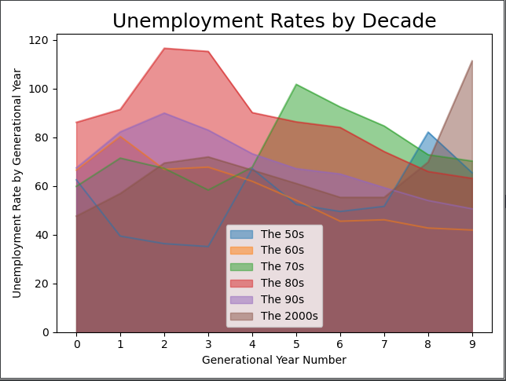

R

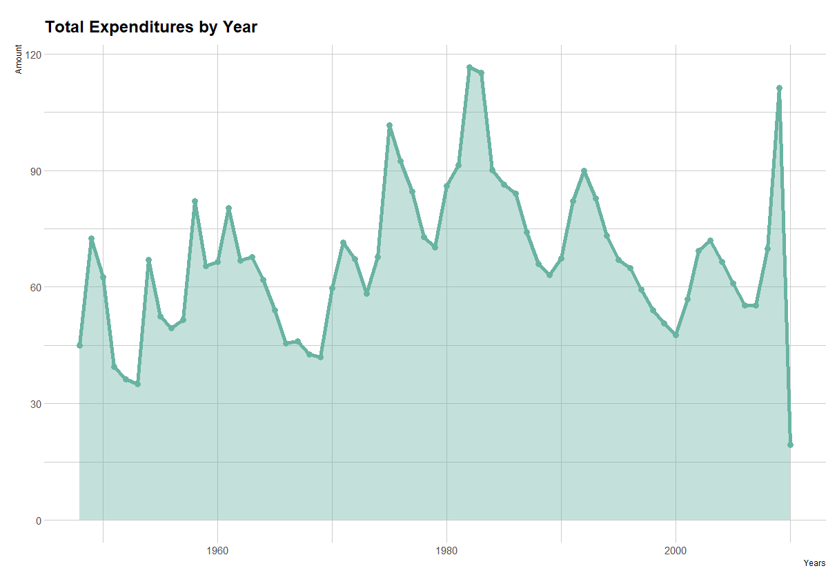

Tableau

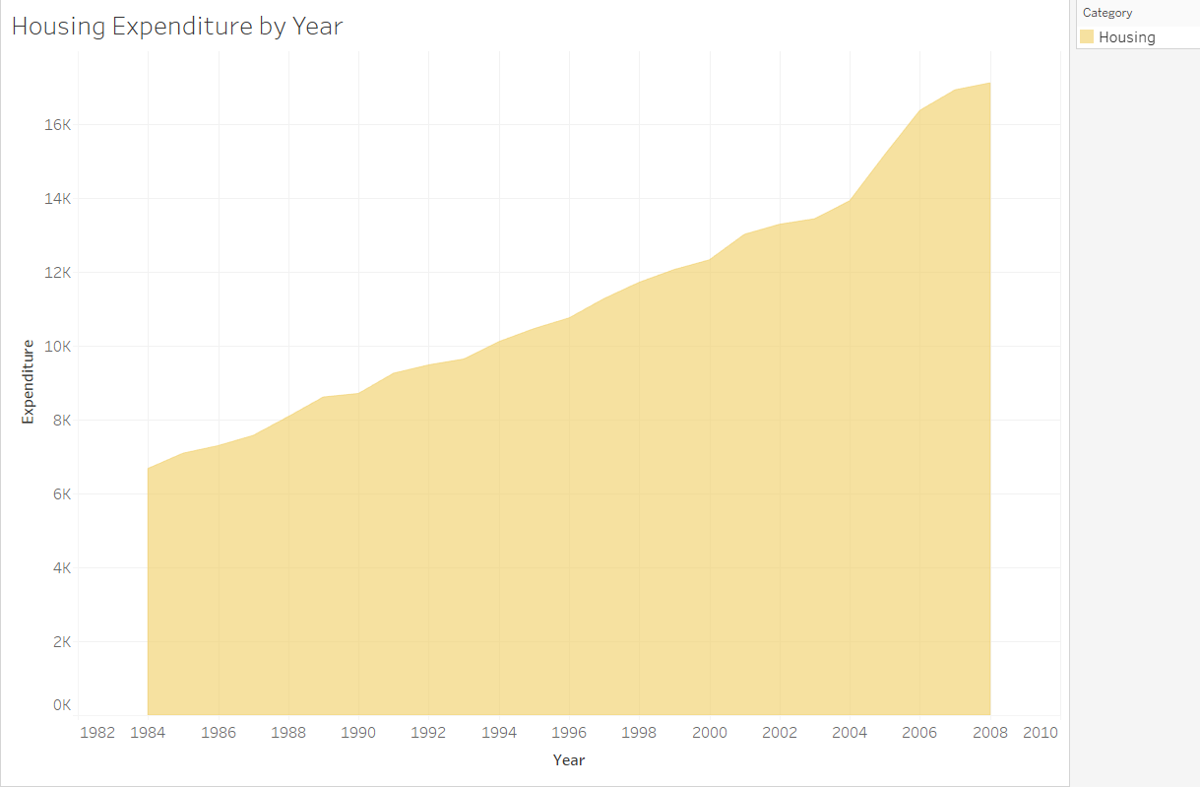

**3 stacked area charts**

Python

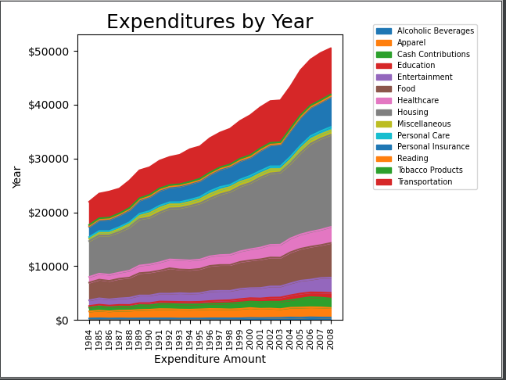

R

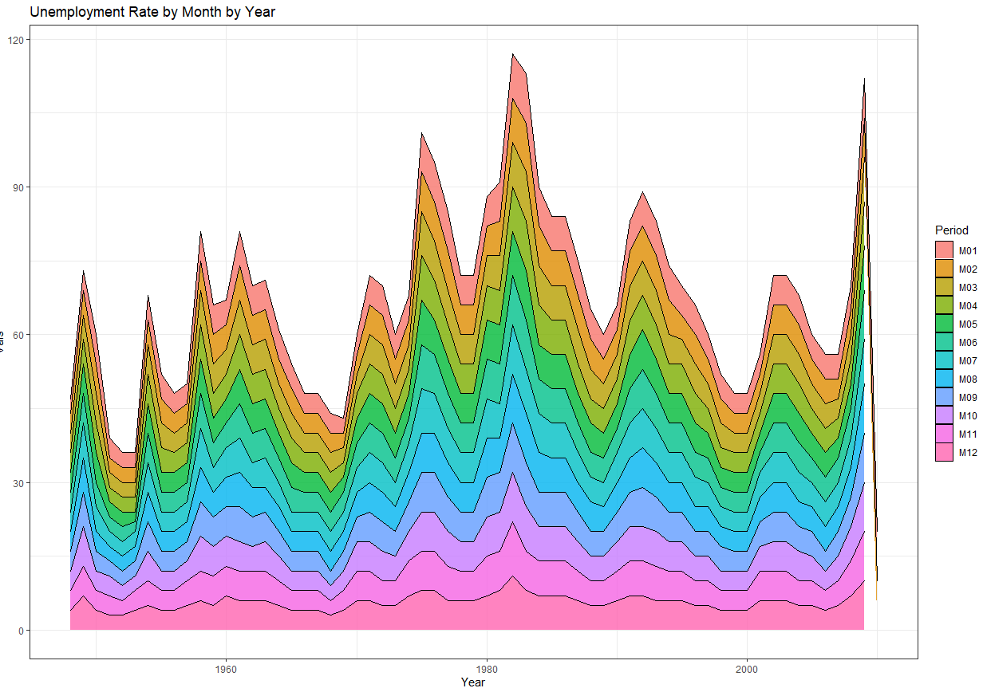

Tableau

